Developing Visualizations

**Activity 1.1**: Water Frequency According to Its Soil Type

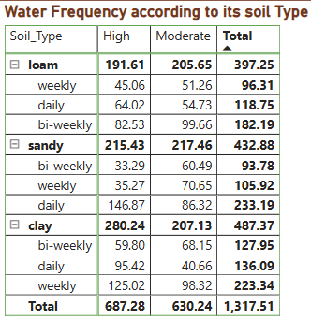

**Insight**: Loam soil with high water frequency results in the highest total water frequency, indicating that loam soil may require or benefit from more frequent watering compared to sandy and clay soils.

**Activity 1.2**: Average Temperature by Temperature Range Description

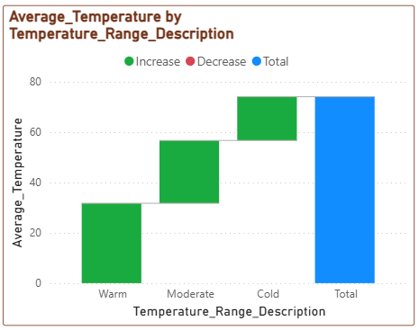

**Insight:**Moderate temperature ranges have the highest average temperature increase, suggesting that plants in this range experience the most growth.

**Activity 1.3:** Temperature and Its Description According to Plant Growth

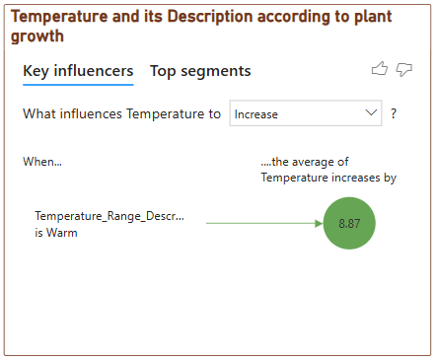

**Insight:** Cold temperature range decreases plant growth, highlighting the negative impact of cold temperatures on plant development.

**Activity 1.4**: Growth Milestone Count by Fertilizer Type

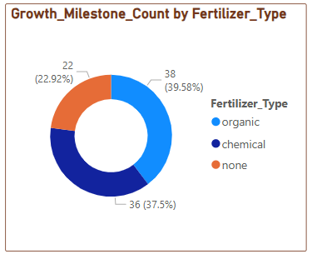

**Insight**: Chemical fertilizers account for the highest growth milestone count, indicating their effectiveness in promoting plant growth milestones compared to organic fertilizers or no fertilizer.

**Activity 1.5**:  Average Humidity by Humidity Level Description

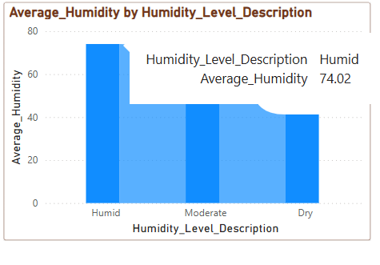

**Insights**: Humid conditions lead to the highest average humidity, emphasizing the importance of maintaining high humidity levels for optimal plant growth.

**Activity 1.6**: Growth Milestone Count According to Its Soil Type

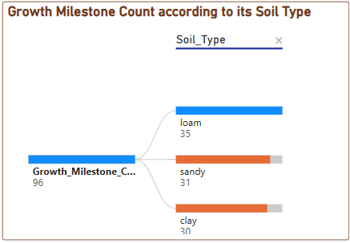

**Insights**: Loam soil has the highest growth milestone count, suggesting it is the most conducive soil type for achieving plant growth milestones.

**Activity 1.7**: Average Sunlight Hours by Soil Type

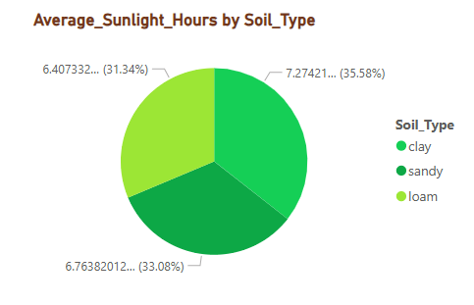

**Insights**: Sandy soil receives the highest average sunlight hours, which may contribute to its growth performance under sufficient light conditions.

**Activity 1.8**: Growth Milestone Percentage by Water Frequency

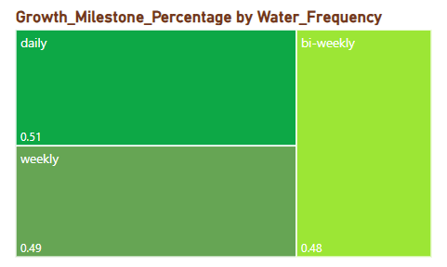

**Insights**: Daily watering results in the highest percentage of growth milestones, showing that frequent watering is crucial for plant growth.

**Activity 1.9**: Growth Milestone Count by Humidity Level Description

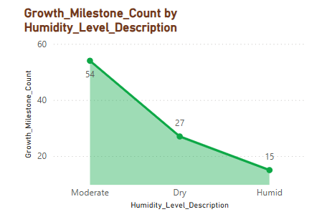

**Insights**: Humid conditions lead to the highest growth milestone count, reinforcing the importance of maintaining adequate humidity levels for optimal growth

**Activity 1.10**: Growth Milestone Count

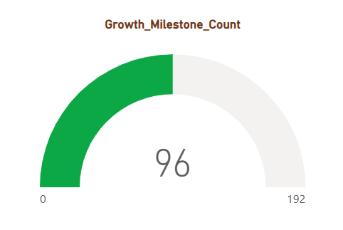

**Insights**: The total growth milestone count is 96, with the highest contributions coming from environments with optimal humidity and temperature conditions.

**Activity 1.11**: Average Humidity, Average Temperature, Average Sunlight Hours

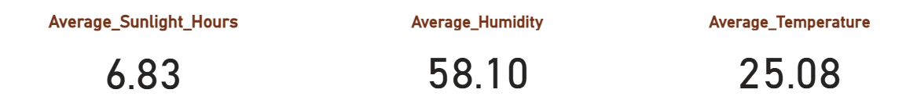

**Insights**: The data indicates a temperate and comfortable climate with an average temperature of 25.08°C, moderate humidity of 58.10%, and a reasonable amount of sunlight averaging 6.83 hours per day.